**Lab 3: System Functions and Frequency Response**

**PART 1: Pole-Zero Diagrams in MATLAB.**

$H\left(s\right)= \frac{s+5}{s^{2}+2s+3}$

clear all;

close all;

b = [1 5]; % Numerator coefficients

a = [2 2 3]; % Demoninator coefficients

zs = roots(b); % Generetes Zeros

ps = roots(a); % Generetes poles

pzmap(ps,zs); % generates pole-zero diagram

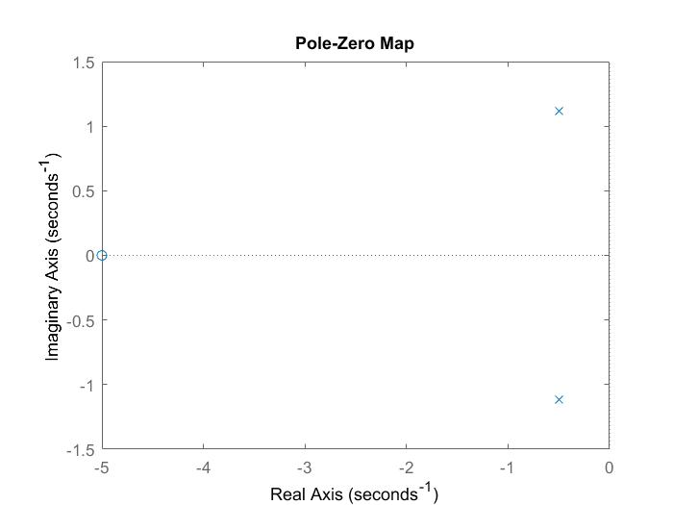

$H\left(s\right)= \frac{{2s}^{2}+5s+12}{s^{2}+2s+10}$

clear all;

close all;

b = [2 5 12]; % Numerator coefficients

a = [1 2 10]; % Demoninator coefficients

zs = roots(b); % Generetes Zeros

ps = roots(a); % Generetes poles

pzmap(ps,zs); % generates pole-zero diagram

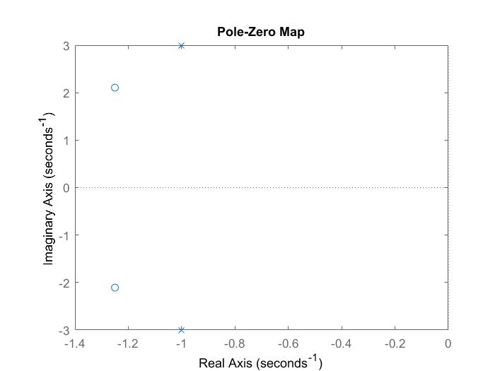

$H\left(s\right)= \frac{{2s}^{2}+5s+12}{{(s}^{2}+2s+10)(s+2)}$

clear all;

close all;

b = [2 5 12]; % Numerator coefficients

a = [1 4 14 20]; % Demoninator coefficients

zs = roots(b); % Generetes Zeros

ps = roots(a); % Generetes poles

pzmap(ps,zs); % generates pole-zero diagram

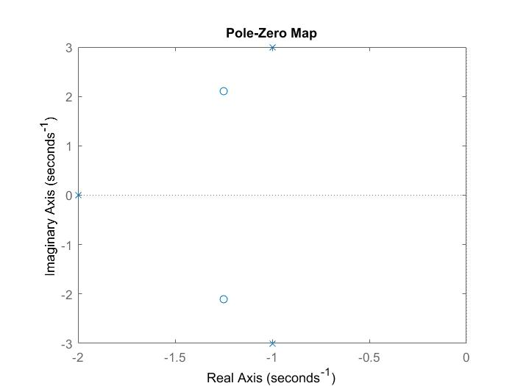

**PART 2: Frequency Response and Bode Plots in MATLAB**

1. Plot the bode plot of each four system functions given in the part 1

$H\left(s\right)= \frac{s+5}{s^{2}+2s+3}$

clear all;

close all;

b = [1 5]; % Numerator coefficients

a = [1 2 3]; % Demoninator coefficients

omega = linspace(-20,20,200);

H = freqs(b,a,omega);

bode(H,omega);

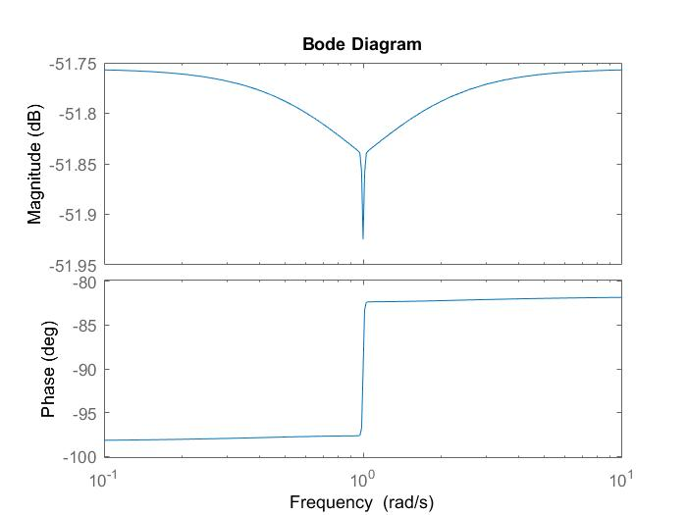

$H\left(s\right)= \frac{{2s}^{2}+5s+12}{s^{2}+2s+10}$

clear all;

close all;

b = [2 5 12]; % Numerator coefficients

a = [1 2 10]; % Demoninator coefficients

omega = linspace(-20,20,200);

H = freqs(b,a,omega);

bode(H,omega);

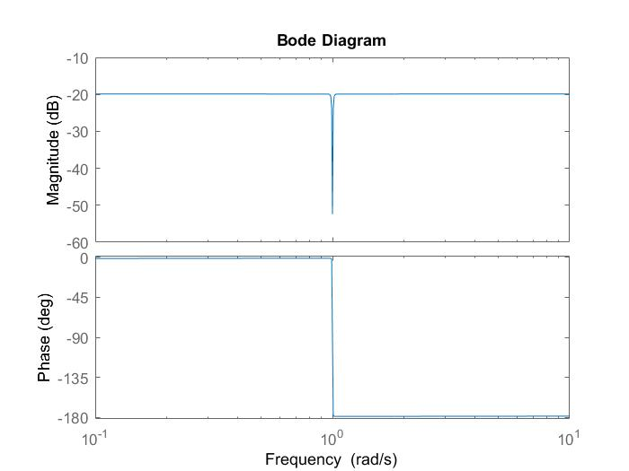

$H\left(s\right)= \frac{{2s}^{2}+5s+12}{{(s}^{2}+2s+10)(s+2)}$

clear all;

close all;

b = [2 5 12]; % Numerator coefficients

a = [1 4 14 20]; % Demoninator coefficients

omega = linspace(-20,20,200);

H = freqs(b,a,omega);

bode(H,omega);

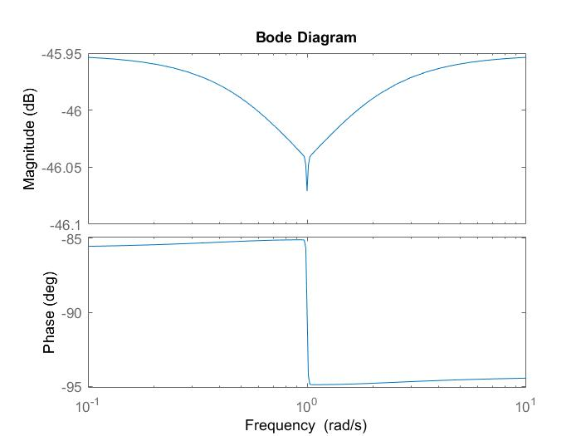

1. Select three sinusoidal signals with unit magnitude, zero phase and three different frequencies (f1, f2, f3 in kHz, here fi = Registration number * i). Assume that they are three inputs for abovementioned four systems. Then find the corresponding three outputs for each system

close all

clear all

b1=[1,-1];

a1=[1,2,2];

b2=[1,5];

a2=[1,2,3];

b3=[2,5,12];

a3=[1,2,10];

b4=[2,5,12];

a4=[1 4 14 20];

for i=1:3

figure

fi=48*i;

t=linspace(0,0.002*pi,20);

x=sin(2*pi*fi*t);

subplot(4,1,1);

sys1=tf(b1,a1,fi);

[y1,t1]=lsim(sys1,x);

plot(t1,y1);

subplot(4,1,2);

sys2=tf(b2,a2,fi);

[y2,t2]=lsim(sys2,x);

plot(t2,y2);

subplot(4,1,3);

sys3=tf(b3,a3,fi);

[y3,t3]=lsim(sys3,x);

plot(t3,y3);

subplot(4,1,4);

sys4=tf(b4,a4,fi);

[y4,t4]=lsim(sys4,x);

plot(t4,y4);

end

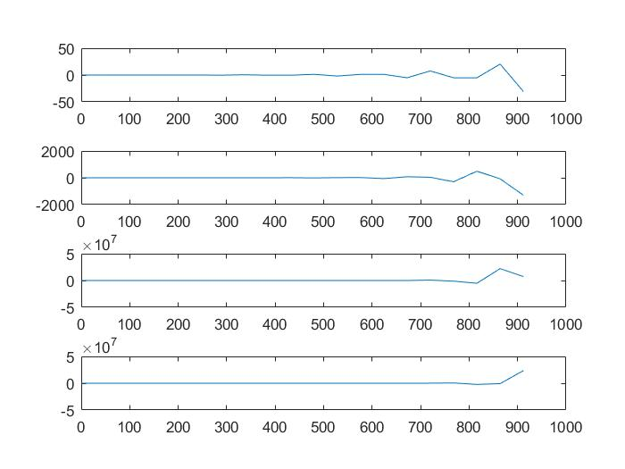 F = 48Hz

F = 48 x 2Hz

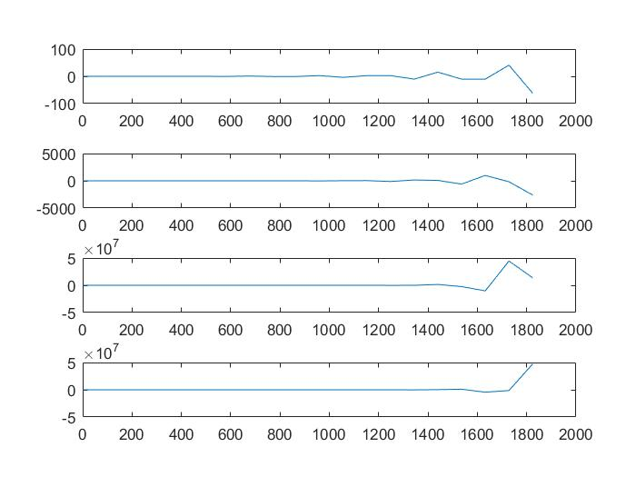

F = 48 x 3Hz

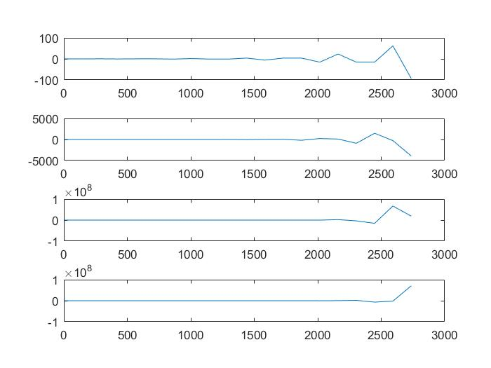

**PART 3: Surface Plots of a System Function in MATLAB**

Where are the poles and zeros on the surface plot? What’s the relationship between the surface plot and the plot in 2.(2) ?

clear all;

close all;

sigma = linspace(-20, 20, 200);

omega = linspace(-5, 5, 200);

[sigmagrid, omegagrid] = meshgrid(sigma, omega);

sgrid = sigmagrid + 1i*omegagrid;

b = [2 2 17];

a = [1 4 104];

H1 = polyval(b, sgrid)./polyval(a, sgrid);

mesh(sigma, omega, 20*log10(abs(H1)));

xlabel('sigma');

ylabel('omega');

zlabel('abs(H1)');

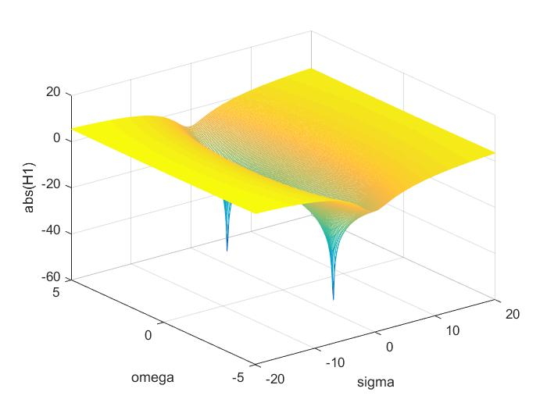

2.2 is the sigma = 0 cross section of this plot (in logarithmic scale)